1. 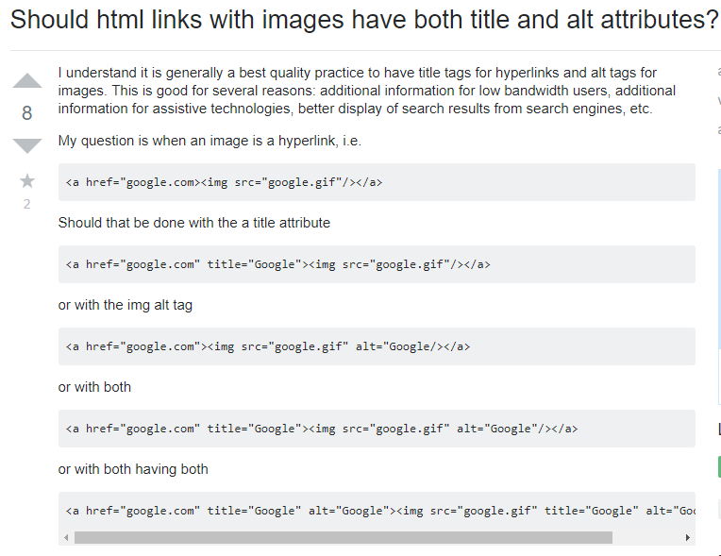Links with images

Use

<a href="google.com"><img src="google.gif" ></a>

to display an image which when clicked on, takes the user to the destination link